# Inheritance

## Type of inheritance

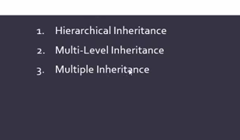

### Hierarchical inheritance:

In this inheritance system, parent class inherited one or more child class, in this inheritance parent class use __init__ method and child class inherit this class, method overriding formula use in here

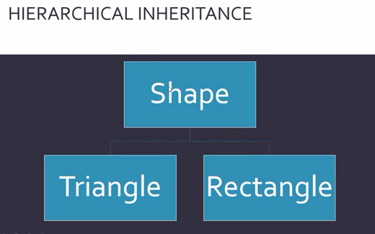

*#herarchic inheritance*

class one:

**def** __init__(*self*,**x**,**y**):

*self*.x**=**x

*self*.y**=**y

**def** fun1(*self*):

        print('i am init class')

class two(*one*):

**def** fun1(*self*):

        print('sum: ', *self*.x**+***self*.y)

class three(*one*):

**def** fun1(*self*):

        print('sub: ', *self*.x**-***self*.y)

lol**=**two(2,2)

lol.fun1()

lol**=**three(3,3)

lol.fun1()

### Multilevel inheritance:

In this inheritance system, parent class inherited child class then the child class inherit next sub child class, it’s also called ladder inheritance system.

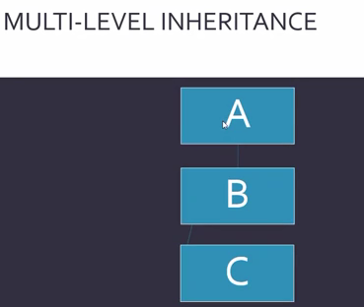

*#multilevel inheritance*

class one:

**def** fun1(*self*):

        print('i am fun1')

class two(*one*):

**def** fun2(*self*):

        print('i am fun2')

class three(*two*):

**def** fun3(*self*):

        print('i am fun3')

lol**=**three()

lol.fun1()

lol.fun2()

lol.fun3()

### Multiple inheritances:

In this inheritance system, parent class inherited one or more child class then there child class inherited one sub child class.

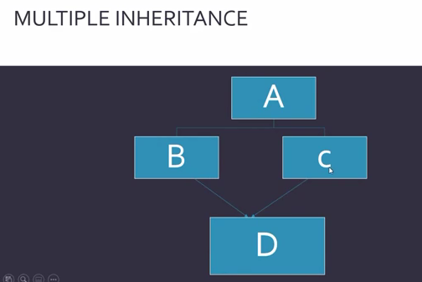

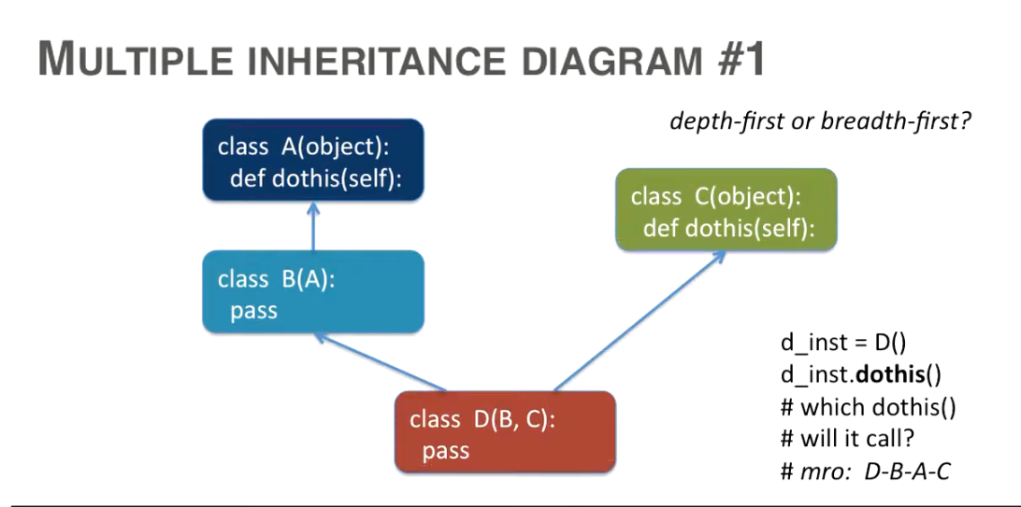

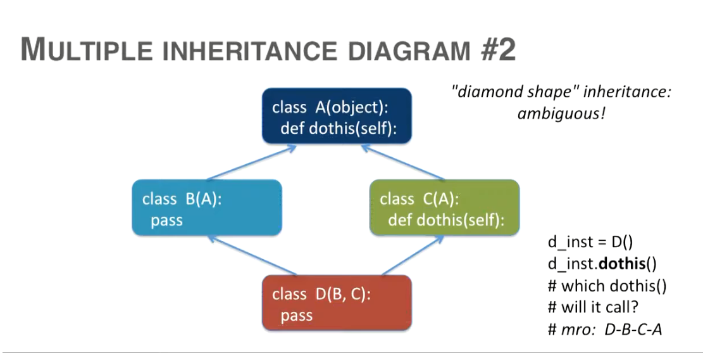

*#multiple inheritance*

class one:

**def** fun1(*self*):

        print('i am fun1')

class two(*one*):

**def** fun2(*self*):

        print('i am fun2')

class three(*one*):

**def** fun3(*self*):

        print('i am fun3')

class four(*two*,*three*):

**def** fun4(*self*):

        print('i am fun4')

lol**=**four()

lol.fun1()

lol.fun2()

lol.fun3()

lol.fun4()